Star Lane Medical Centre

GP Surgery

Access to Medical Records

1. AIM

You have a right, under the General Data Protection Regulation, to access the personal data we hold on you. To do so, you should made a subject access request, and this policy sets out how you should make a request, and our actions upon receiving the request.

1. **DEFINITIONS**

“Personal data” is any information relating to an identifiable person who can be directly or indirectly identified in particular by reference to an identifier, including your name.

“Special categories of personal data” includes information relating to:

1. race
2. ethnic origin
3. politics
4. religion
5. trade union membership
6. genetics
7. biometrics (where used for ID purposes)
8. health
9. sex life or
10. sexual orientation
11. **MAKING A REQUEST**

Although subject access requests may be made verbally, we would advise that a request may be dealt with more efficiently and effectively if it is made in writing. If you wish to make a request, please use the Subject Access Request form.

Requests that are made directly by you should be accompanied by evidence of your identity. If this is not provided, we may contact you to ask that such evidence be forwarded before we comply with the request.

Requests made in relation to your data from a third party should be accompanied by evidence that the third party is able to act on your behalf. If this is not provided, we may contact the third party to ask that such evidence be forwarded before we comply with the request.

1. **TIMESCALES**

Usually, we will comply with your request without delay and at the latest within one month. Where requests are complex or numerous, we may contact you to inform you that an extension of time is required. The maximum extension period is two months.

1. **FEE**

We will normally comply with your request at no cost. However, if the request is manifestly unfounded or excessive, or if it is repetitive, we may contact you requesting a fee. This fee must be paid in order for us to comply with the request. The fee will be determined at the relevant time and will be set at a level which is reasonable in the circumstances.

In addition, we may also charge a reasonable fee if you request further copies of the same information.

1. **INFORMATION YOU WILL RECEIVE**

When you make a subject access request, you will be informed of:

* 1. Whether or not your data is processed and the reasons for the processing of your data;
  2. The categories of personal data concerning you;
  3. Where your data has been collected from if it was not collected from you;
  4. Anyone who your personal data has been disclosed to or will be disclosed to, including anyone outside of the EEA and the safeguards utilised to ensure data security;
  5. How long your data is kept for (or how that period is decided);
  6. Your rights in relation to data rectification, erasure, restriction of and objection to processing;
  7. Your right to complain to the Information Commissioner if you are of the opinion that your rights have been infringed;
  8. The reasoning behind any automated decisions taken about you.

1. **CIRCUMSTANCES IN WHICH YOUR REQUEST MAY BE REFUSED**

We may refuse to deal with your subject access request if it is manifestly unfounded or excessive, or if it is repetitive. Where it is our decision to refuse your request, we will contact you without undue delay and at the latest within one month of receipt, to inform you of this and to provide an explanation. You will be informed of your right to complain to the Information Commissioner and to a judicial remedy.

We may also refuse to deal with your request, or part of it, because of the types of information requested. For example, information which is subject to legal privilege or relates to management planning is not required to be disclosed. Where this is the case, we will inform you that your request cannot be complied with and an explanation of the reason will be provided.

**Please use SAR form below for to view or request copy of medical records.**

**SUBJECT ACCESS REQUEST FORM**

Please complete the application form in **BLOCK LETTERS**.

**Section 1: Details of the data subject (patient)**



|  |  |  |  |  |  |  |  |
| --- | --- | --- | --- | --- | --- | --- | --- |
| Surname |  |  |  |  | Title |  |  |
|  |  |  |  |  |  |  |  |
| Forename(s) |  |  |  |  |  |  |  |
|  |  |  |  |  |  |  |  |
| Former names |  |  |  |  |  |  |  |
|  |  |  |  |  |  |  |  |
| Date of birth |  |  |  |  |  |  |  |
|  |  |  |  |  |  |  |  |
| Hospital number |  |  |  |  |  |  |  |
|  |  |  |  |  |  |  |  |
| Current address |  |  |  |  |  |  |  |
|  |  |  |  |  |  |  |
|  |  |  |  |  |  |  |
|  |  |  |  |  | |  |  |
|  | Country |  |  | Post Code | | |  |
|  |  |  |  |  |  |  |  |
| Previous address |  |  |  |  |  |  |  |
|  |  |  |  |  |  |  |
|  |  |  |  |  |  |  |
|  |  |  | |  | |  |  |
|  | Country |  |  | Post Code | | |  |
|  |  |  |  |  |  |  |  |
| Telephone/mobile n° |  |  |  |  |  |  |  |
|  |  |  |  |  |  |  |  |
| Email address |  |  |  |  |  |  |  |
|  |  |  |  |  |  |  |  |
|  |  |  | |  |  |  |  |
| **Section 2: Details of person acting on behalf of data subject (patient)** | | | |  |  |  |  |
| Surname |  |  | |  | Title |  |  |
|  |  |  | |  |  |  |  |
| Forename(s) |  |  |  |  |  |  |  |
|  |  |  | |  |  |  |  |
| Current address |  |  |  |  |  |  |  |
|  |  |  |  |  |  |  |
|  |  |  |  |  |  |  |
|  |  |  | |  | | |  |
|  | Country |  |  | Post Code | | |  |
|  |  |  |  |  |  |  |  |
| Previous address |  |  |  |  |  |  |  |
|  |  |  |  |  |  |  |
|  |  |  |  |  |  |  |
|  |  | | |  | | |  |
|  | Country |  |  | Post Code | | |  |
|  |  |  |  |  |  |  |  |
| Telephone/mobile n° |  |  |  |  |  |  |  |
|  |  |  | |  |  |  |  |
| Email address |  |  |  |  |  |  |  |
|  |  |  | |  |  |  |  |
| ICO data controller |  |  |  |  |  |  |  |
| registration number |  |  | |  |  |  |  |
| (if applicable) |  |  | |  |  |  |  |



**Section 3: Your relationship to the patient**



Please tick appropriate box:

* I have been asked to act by the patient and attach the patient’s written authorisation.
* I have parental responsibilities for the patient who is a minor (under 16 years old)—I have attached a court order.
* I have been appointed as the Mental Capacity Advocate for this patient and wish to access copies of their records—I have attached confirmation of my appointment.
* I have been appointed by a court to manage the affairs of the patient—I have attached confirmation of my appointment.
* I am the deceased patient’s personal representative—I have attached confirmation of my appointment.
* I have a claim arising from the patient’s death and wish to access information relevant to my claim—I have attached an explanation of the claim being considered.
* Other—please state:

**Section 4: Description of information requested**

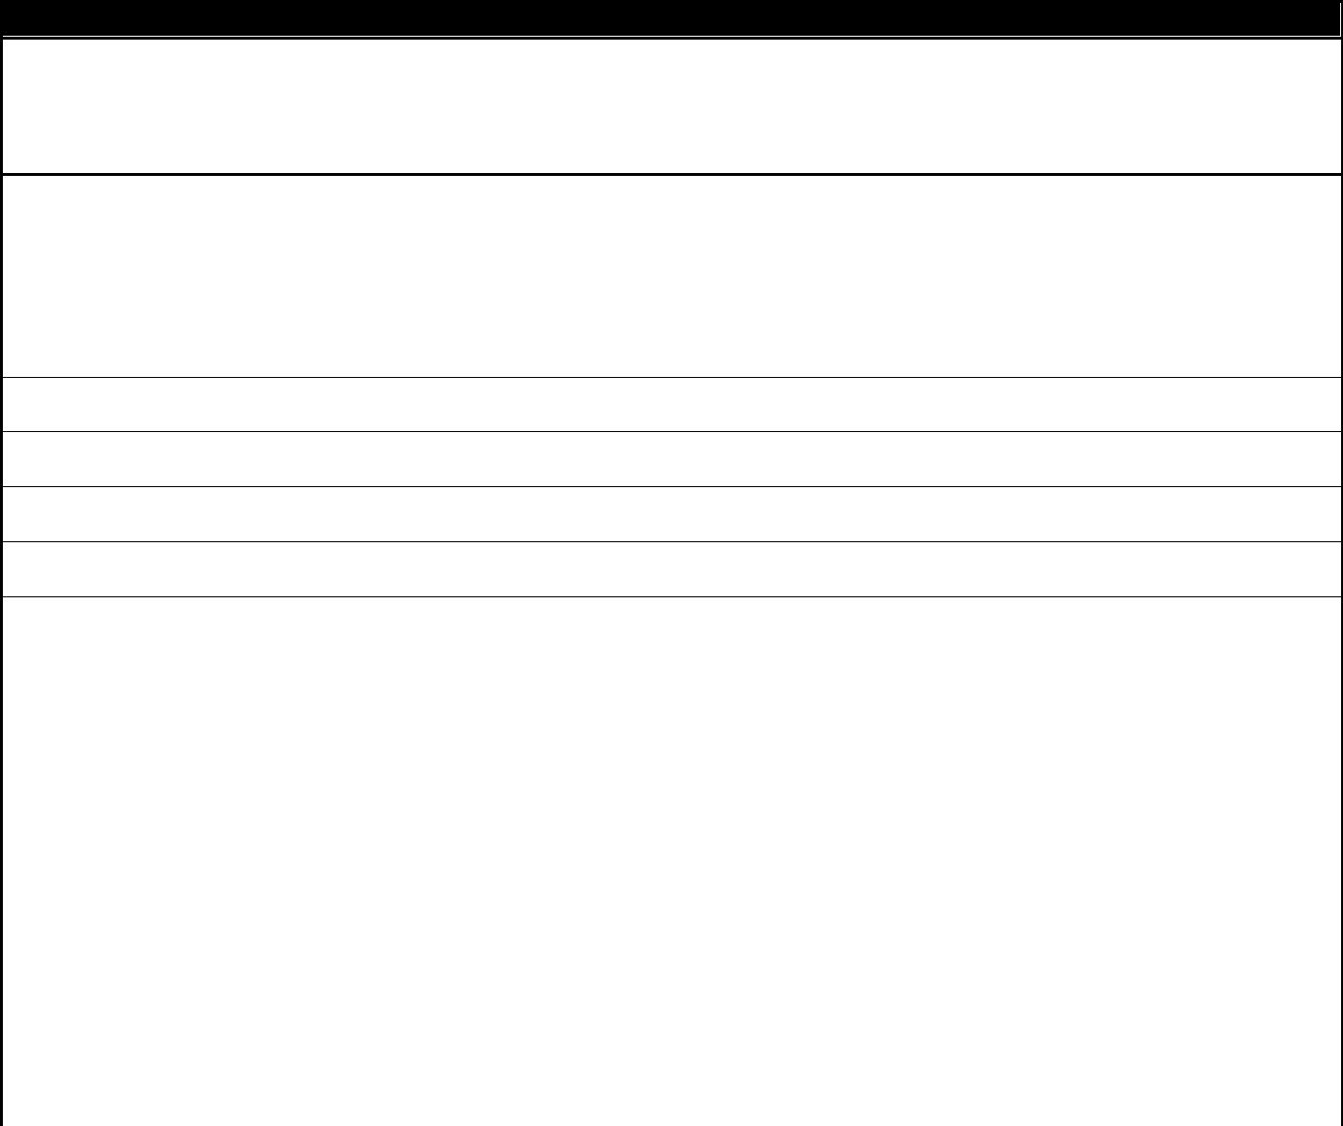

 

Please tick the appropriate box to indicate if you wish to access:

□ ALL records

□ Specific records regarding the treatment of a condition/illness (please state below) and the approximate date (continue on a separate sheet if necessary):

|  |  |
| --- | --- |
| Please tick ALL relevant boxes to indicate which | □ Medical records |
| types of records you wish to access: | □ Consultations |
|  | □ Referral |
|  | □ Results |
|  | □ Brief Summary |
|  | □ Full Summary |
|  | □ Medication |
|  | □ Allergies |
|  | □ Immunisations |
|  | □ Brief Summary with attachments |
|  | □ Full Summary with attachments |
| Please tick the appropriate box to indicate if you | □ I would like copies of the records |
| would you like copies of these records or just to | □ I would like to view the records |
| view them: |  |

Page **4** of **6**

**Section 5: Declaration—please complete either Part A, B or C**



**Part A: I am the data subject/legal parent/guardian of the data subject who is a minor** (strike offas appropriate)

I, the undersigned declare that the information given by me is correct to the best of my knowledge and that I am entitled to apply under the Data Protection Act 1998 for access to personal data that the SLMC me under the terms of that Act. I understand that it is necessary for SLMC to confirm my identity and it may be necessary to obtain more detailed information to confirm my identity and/or locate the correct information.

Full name (print): __________________________________________________________________

Signed: __________________________________________ Date (print): ____________________

**Part B: I am the data subject giving authority to a representative to act on my behalf.**

I have been asked to act by the data subject and below is the data subject’s written authorisation.

I hereby give my consent for the below named to make a Subject Access Request (SAR) on my behalf under the Data Protection Act 1998 to. I am aware that it is an offence to unlawfully obtain such information—for example, by impersonating the patient. I certify that the information given in this form is true.

Full name of data subject (print): ______________________________________________________

Signed: __________________________________________ Date (print): ____________________

Full name of representative (print): ____________________________________________________

Signed: __________________________________________ Date (print): ____________________

**Part C: I am requesting access to:**

__________________________________________________ **(full name of deceased patient)**

I declare that the information given by me is correct to the best of my knowledge and I am entitled to apply under Access to Health Records Act 1990 because:

* I have a claim arising from the data subject’s death and wish to access information relevant to my claim and attach details of the grounds of my claim (please provide documentary information)
* I am a personal representative
* I am an executor

Full name of requestor (print): ________________________________________________________

Signed: __________________________________________ Date (print): ____________________

Page **5** of **6**

**Section 6: Supporting documents and identification**



In order to confirm your identity, you will need to send us:

* the original or a certified copy of one of the documents from the proof of identity list below
* one item from the **proof of address** list below

Please tick the appropriate box to indicate which document you have enclosed:

|  |  |  |  |  |
| --- | --- | --- | --- | --- |
|  | **Proof of identity** | **Proof of address** |  |  |
|  |  |  |
|  | □ Current passport | □ Utility bill (no more than 3 months old) |  |  |
|  | □ Current photocard driving licence | □ Council tax bill for current year |  |  |
|  | □ Current EU driving licence | □ Current benefit book or card, or original |  |  |
|  | □ HM Forces ID card | notification from the Department of Work and |  |  |
|  |  | Pensions confirming rights to benefits |  |  |
|  |  | □ Recent bank statement (no more than 3 |  |  |
|  |  | months old) |  |  |
|  |  |  |  |  |
|  | **For deceased patients only:** |  |  |  |

In addition to providing evidence of his/her identity, the applicant is required to provide evidence as indicated below. Please tick the appropriate box to indicate which document(s) you have enclosed:

* **Executor of the will:** Copy of the last will executed by the deceased person, certified by asolicitor, showing the applicant named as executor
* **Letters of Administration:** Copy of such letters, certified by a solicitor, naming the applicant ashaving been granted letters of administration in respect of the deceased’s estate
* **Details of the grounds of a claim** which the applicant is entitled to make, arising from the deathof the deceased data subject

Page **6** of **6**